Group: Tennis Club 2

Project 3

**Software Requirements Specification**

**Version 5.0**

**Revision History**

|  |  |  |
| --- | --- | --- |
| **Date** | **Version** | **Changelog** |
| 11.09.2022 | 1.0 | Introduction |
| 18.09.2022 | 1.1 | General Structure |
| 26.09.2022 | 2.0 | Chapter 2 |
| 02.10.2022 | 3.0 | Chapter 3 Beginning |
| 08.10.2022 | 4.0 | Finalized |
| 23.11.2022 | 5.0 | Rewritten |

**Table of Contents**

1. Introduction 5

1.1 Purpose 5

1.2 Scope 5

1.3 Definitions, Acronyms and Abbreviations 5

1.4 References 6

1.5 Overview 6

2. General Description 7

2.1 Product Perspective 7

2.2 Product Functions 7

2.3 Use Characteristics 7

2.4 General Constraints 7

2.5 Assumptions & Dependencies 7

3. Specific Requirements 8

3.1 External Interface Requirements 8

3.1.1 User Definition 8

3.1.2 User Interfaces 8

3.1.3 Hardware Interfaces 8

3.1.4 Software Interfaces 9

3.1.5 Communication Interfaces 9

3.2 Functional Requirements 10

3.2.1 System Feature 1: Search Match 10

3.2.2 System Feature 2: View Match 11

3.2.3 System Feature 3: Initiate Match 12

3.2.4 System Feature 4: Finalize Match 13

3.2.5 System Feature 5: Update Match 14

3.3 Performance Requirements 15

3.4 Design constraints 15

3.5 Software System Attributes 16

3.5.1 Reliability 16

3.5.2 Availability 16

3.5.3 Security 16

3.5.4 Maintainability 16

3.5.5 Portability 17

4 Additional Material 18

4.1 Use-Case Diagram 18

4.1 Activity Diagram 19

**Software Requirements Specification**

# 1. Introduction

The following Software Requirements Specification (SRS) will describe the solution of group 2 to the need of the tennis club to replace the old, used system for storing information of played matches. This solution will also improve the efficiency of fetching data from already played tennis matches. The topics that are covered in this SRS are: an introduction to the problem that the client currently has with the current system, the solution suggested by the team for these problems as well as specific system and client requirement, which are defined by the group.

## 1.1 Purpose

The purpose of the product resulting from this document is to solve the problem given by the tennis club regarding tracking and archiving matches. The product will be an online service replacing the archive which is currently used by the club. This way the archive will be held online and reduce resources and time when searching a specific game. The application will be used by referees during a tennis match.

## 1.2 Scope

This application will be a Web service for the tennis club. It will be primarily used by the referees during a tennis match. The application will be designed to help referees and maximise the efficiency regarding archiving the information of matches.

More specifically, the application is designed to gather information regarding player, points and timestamps of a tennis match and save this information in a database which will be replacing the existing archive. The application will simplify the process of gathering information for the referee to maximise the workflow of the referee while increasing the safety of the data massively. When stored in the database, the information can be seen and print a report of a match on paper when needed. The system will also give specific information to the media when a match is televised.

## 1.3 Definitions, Acronyms and Abbreviations

|  |  |
| --- | --- |
| Word / Abbreviation | Definition |
| SRS (Software Requirements Specification) | A document of a system that is yet to be created. The document defines functional and non-functional requirements that needs to be met by the system. The SRS also defines specific Use Cases that describe how the end-user would interact with the system |
| Love | In tennis: score of zero |
| Advantage (adv.) | In tennis: a score when the team wins the following point. Can only happen when the game is in a deuce |
| Deuce | In tennis: both teams have a score of 40 points |
| Database | A database is a structured set of data held by a system |

## 1.4 References

Reference 1:

* Title: How does tennis score work? | Tennis score explained
* Report Number: -
* Date: April 30, 2022
* Publishing Organization: Super Tennis Racquet – Robert Dexter
* Link: <https://supertennisracquet.com/how-does-tennis-score-work/>

Reference 2:

* Title: Tennis ranking system: how does it work? WTA & ATP explanations
* Report Number: -
* Date: January 1, 2022
* Publishing Organization: Super Tennis Racquet – Robert Dexter
* Link: <https://supertennisracquet.com/tennis-ranking-system/>

## 1.5 Overview

This SRS will now continue by explaining the specifics of the software system being produced. The next Section will discuss the context of the proposed system, the function of said system and what the related constraints are, while Section 3 will explain the requirements that were defined for the system.

# 2. General Description

The following chapter will examine all necessary information of the system that is proposed by group 2. These necessary information contain functions, a perspective and relevant constraints.

## 2.1 Product Perspective

The system will be used to record information from a playing tennis match and store these captured information in a database. These information can be accessed later by the general public, but not be changeable. This system will improve the security massively, because this way it is impossible to change the data once it is stored in the database. To track the data from an ongoing match, there will be an offline application that will be used by the referees. As soon as the match is done and the used device has an internet connection, all tracked information will be uploaded to the database.

## 2.2 Product Functions

The finalized system will begin by asking the referee to initiate a match. In this initiation the referee is able to enter all necessary information, such as player and their corresponding clubs. After that the system changes to an interface where the referee is able to enter points to update the scores of the players. When the match is ended, the referee will close the match in the application and the match is saved locally to the device. As soon as the device has an internet connection, the match with the saved information will be uploaded to the database where it is saved invariably. From here a match can be found by using the search function of the system. By entering key information such as player name or dates, the user is able to search and find past matches.

## 2.3 Use Characteristics

This system will mainly focus on two major users. The first user will be the referee who is able to initiate and end a match and adding points to the score of a match. The second user is going to be the general public who are only be given the right to search a match to retrieve information that is stored in the database.

## 2.4 General Constraints

The finalized system requires an internet connection to upload a finalized match, but does not require an internet connection to be able to initiate, update and end a match. To meet the safety concerns of the tennis club, the system makes it impossible to alter match data that is already saved in the database.

## 2.5 Assumptions & Dependencies

In order to work properly, the system assumes that there is an internet connection at some point after a match. Also, the referee needs to have access to a device. It does not matter if it is a smartphone, a tablet or a laptop, as long as it can connect to the internet and is able to run the application.

# 3. Specific Requirements

This chapter is going to cover all specified requirements of the application. Software, Hardware and User requirements are taken into account.

## 3.1 External Interface Requirements

This section will cover all external interface requirements that needs to be met, so that the product will work as expected.

## 3.1.1 User Definition

3.1.1.1 Referee: A referee will use the application to track matches. Can access system features 2, 3, 4 and 5.

3.1.1.2 Club Manager: The club manager acts as an admin. Can access every system feature and has overview over database.

3.1.1.3 Media: The media gets information of an ongoing match. Can access system feature 1 and information of an ongoing match.

3.1.1.4 Other: This is the user that can look up already played matches. Can access system feature 1.

### 3.1.2 User Interfaces

3.1.2.1 High Priority: When initiating a match, the actor shall provide two names for the players and two clubs that are associated to the players.

3.1.2.2 High Priority: During a match, the actor shall use the options to add points to the given players. The actor is able to pause a match when needed. When a match is done, the actor must close the match.

3.1.2.3 High Priority: When a match is closed, the actor must connect to the internet to upload the locally saved match. The actor shall not be able access the locally saved match under any circumstances.

3.1.2.4 Low Priority: Actor will search a saved match on the website. The actor will click on a found match related to the given search item to access a site with more information about that match.

### 3.1.3 Hardware Interfaces

3.1.3.1 High Priority: The device that is used for tracking matches shall meet the following requirements: Capable of connecting to the internet; CPU that is capable of running a speed faster than 2 GHz; At least 4 GB of RAM; At least 1 GB of system storage available.

- This ensures that only devices that have decent performance can be used with our application.

3.1.3.2 Low Priority: For the website, actor shall use a device that can connect to the internet.

- This ensures high Accessibility.

### 3.1.4 Software Interfaces

3.1.4.1 Low Priority: For the device that is used for tracking the match, it does not matter which operating system the device is running on (iOS, Windows, Android), as long as 3.1.3.1 is fulfilled.

- This ensures a high variety of devices that are usable.

### 3.1.5 Communication Interfaces

3.1.5.1 The application shall use an HTTPS connection.

- This ensures a secure connection.

## 3.2 Functional Requirements

### 3.2.1 System Feature 1: Search Match

**3.2.1.1 Introduction / Purpose of Feature**

This feature gives the option to search a match that is already played and uploaded into the database. With this feature, everyone that is interested can search up a match that has already taken place.

* + - 1. **Stimulus / Response Sequence**

1. System asks actor to select a date
2. Actor selects date
3. System shows all matches of that day

**3.2.1.3 Associated Functional Requirements**

Requirement 3.1.2.4, Requirement 3.1.3.2

### 3.2.2 System Feature 2: View Match

**3.2.2.1 Introduction / Purpose of Feature**

With this feature, a user can look up specific information about a played match. This information shall contain:

* The score
* The rounds
* Player name and club

This feature shall only be accessed after feature 1 is complete

**3.2.2.2 Stimulus / Response Sequence**

1. The user selects a match that has taken place
2. The system displays the match's page and the match's data.

**3.2.2.3 Associated Functional Requirements**

Requirement 3.1.2.4, Requirement 3.1.3.2

### 3.2.3 System Feature 3: Initiate Match

**3.2.3.1 Introduction/Purpose of Feature**

This feature is a key feature of this software. With this feature, a new match instance shall be created and made available for now or later use. The match shall contain the following information:

* Club Names
* Match Date
* Sets required to win

Optionally the match can contain:

* Team (e.g., U17-1 for age under 17 team 1, U17-2 for age under 17 team 2)
* Player Name (As GDPR)

**3.2.3.2 Stimulus/Response Sequence**

1. Actor selects option to initiate new match
2. System requests Actor to provide match data (Club names, match date, sets to win)
3. Actor provides match data (Club Names, match date, sets to win)
4. Actor selects to create match
5. System adds new match

**3.2.3.3 Associated Functional Requirements**

Requirement 3.1.2.1, Requirement 3.1.3.1, Requirement 3.1.4.1

### 3.2.4 System Feature 4: Finalize Match

**3.2.4.1 Introduction/Purpose of Feature**

With this feature, the match data given by the referee throughout the match shall be collected and directly uploaded to the database. In the database the data shall be stored and be available for everyone. This way it is ensured that the data shall be stored correctly in the database and shall not be changed during the process of archiving.

**3.2.4.2 Stimulus/Response Sequence**

1. Actor selects option to close the game.
2. System checks given data and asks actor for confirmation.
3. Actor confirms.
4. System collects given data and uploads data to the database.

**3.2.4.3 Associated Functional Requirements**

Requirement 3.1.2.1, Requirement 3.1.2.2, Requirement 3.1.2.3, Requirement 3.1.3.1, Requirement 3.1.4.1, Requirement 3.1.5.1

### 3.2.5 System Feature 5: Update Match

**3.2.5.1 Introduction/Purpose of Feature**

Through this feature, the user shall update the scores of an ongoing match. It also allows to update already given information about players, team or clubs.

**3.2.5.2 Stimulus/Response Sequence**

1. Actor selects ongoing game to update.
2. System displays current game information.
3. Actor changes team names and/or scores.
4. Actor indicates that they want to finalize the match.
5. System asks for confirmation.
6. Actor confirms.
7. System finalizes match information and returns the actor to the match list.

**3.2.5.3 Associated Functional Requirements**

Requirement 3.1.2.1, Requirement 3.1.2.2, Requirement 3.1.3.1, Requirement 3.1.4.1

## 3.3 Performance Requirements

3.3.1 Low Priority: Uploading, searching or displaying a match should take no more than three seconds for 95% of the total requests.

- This ensures high performance when searching a match.

3.3.2 High Priority: Creating a match shall take no longer than one second.

- This ensures high performance for the referee.

## 3.4 Design constraints

* Our budget for this job is maximum 10.000 euro for the entire project.
* This system should be finished by January 2023.
* The system’s analysis and design phase should take 8 weeks
* The system’s implementation should take 8 weeks
* The system’s security must be a high-level priority as that is the main reason for the development of this application.
* The system must be simple and intuitive for an umpire to perform their duty.
* The system’s functionality will be separated based on who is using it.
* Information initially saved to match should not be able to be changed in order to uphold the integrity of the information and prevent cheating.

## 3.5 Software System Attributes

### 3.5.1 Reliability

3.5.1.1 Functional: The product shall only provide valid data which shall be checked by at least one person.

- This ensures reliable data.

### 3.5.2 Availability

3.5.2.1 Functional: The product shall be available through an online webservice.

- This ensures that the application is accessible from everywhere.

### 3.5.3 Security

3.5.3.1 Functional: The product shall deny access to non-authenticated users.

- This ensures that the product cannot be used by unauthorized people.

3.5.3.2 Functional: The product shall not allow updates to already saved records.

- This ensures high security on already saved matches.

3.5.3.3 Functional: The product shall use https encryption.

- This ensures a secure connection.

3.5.3.4 Functional: The product shall create a log which saves who created a specific match at a specific time.

- This ensures knowledge of who saved when which match.

3.5.3.5 Functional: The product shall eliminate interferences while saving records.

- This ensures safe data that is not influenced by other data.

3.5.3.6 Non-Functional: The product shall follow the guidelines of the GDPR.

- This ensures a legal foundation.

### 3.5.4 Maintainability

3.5.4.1 Non-Functional: The product shall provide high maintainability for the referee by allowing various options while creating, tracking and saving a match.

- This ensures high Maintainability for the product.

### 3.5.5 Portability

3.5.5.1 Non-Functional: The product shall be available on websites.

- This ensures high Accessibility and Portability.

# 4 Additional Material

This chapter will provide further additional sources that were created during the process of creating the product.

## 4.1 Use-Case Diagram

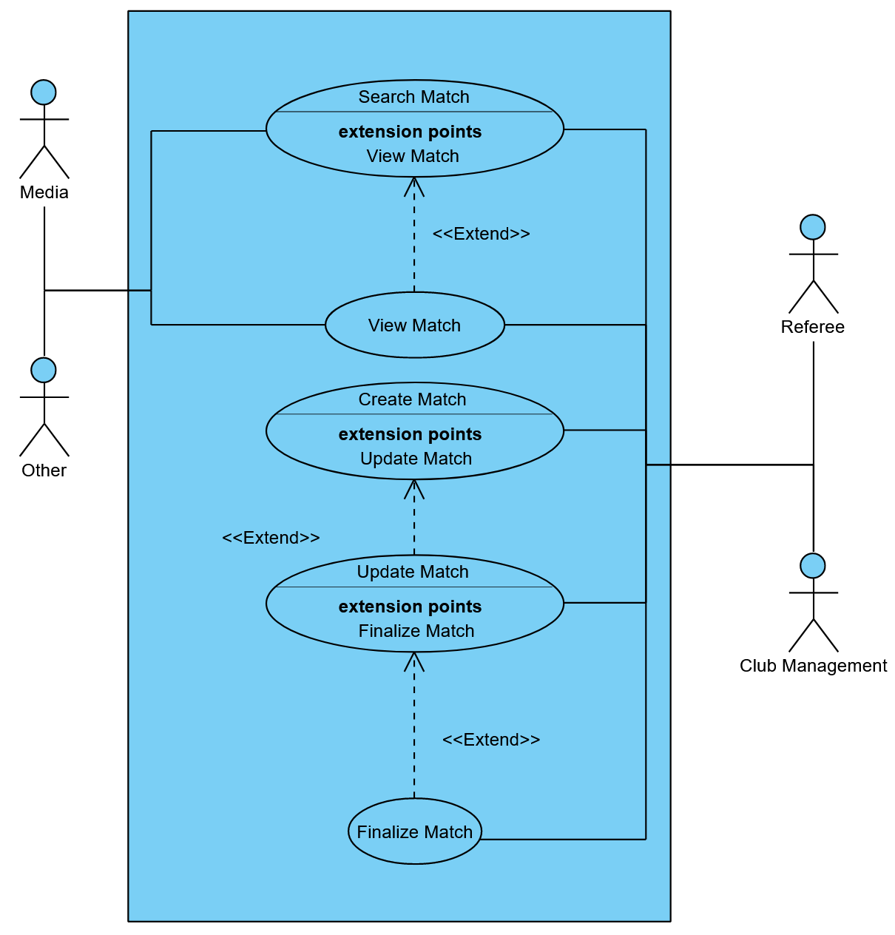The following Use-Case Diagram visualizes how the system features are connected to each other and what user group can trigger which system feature.

## 4.1 Activity Diagram

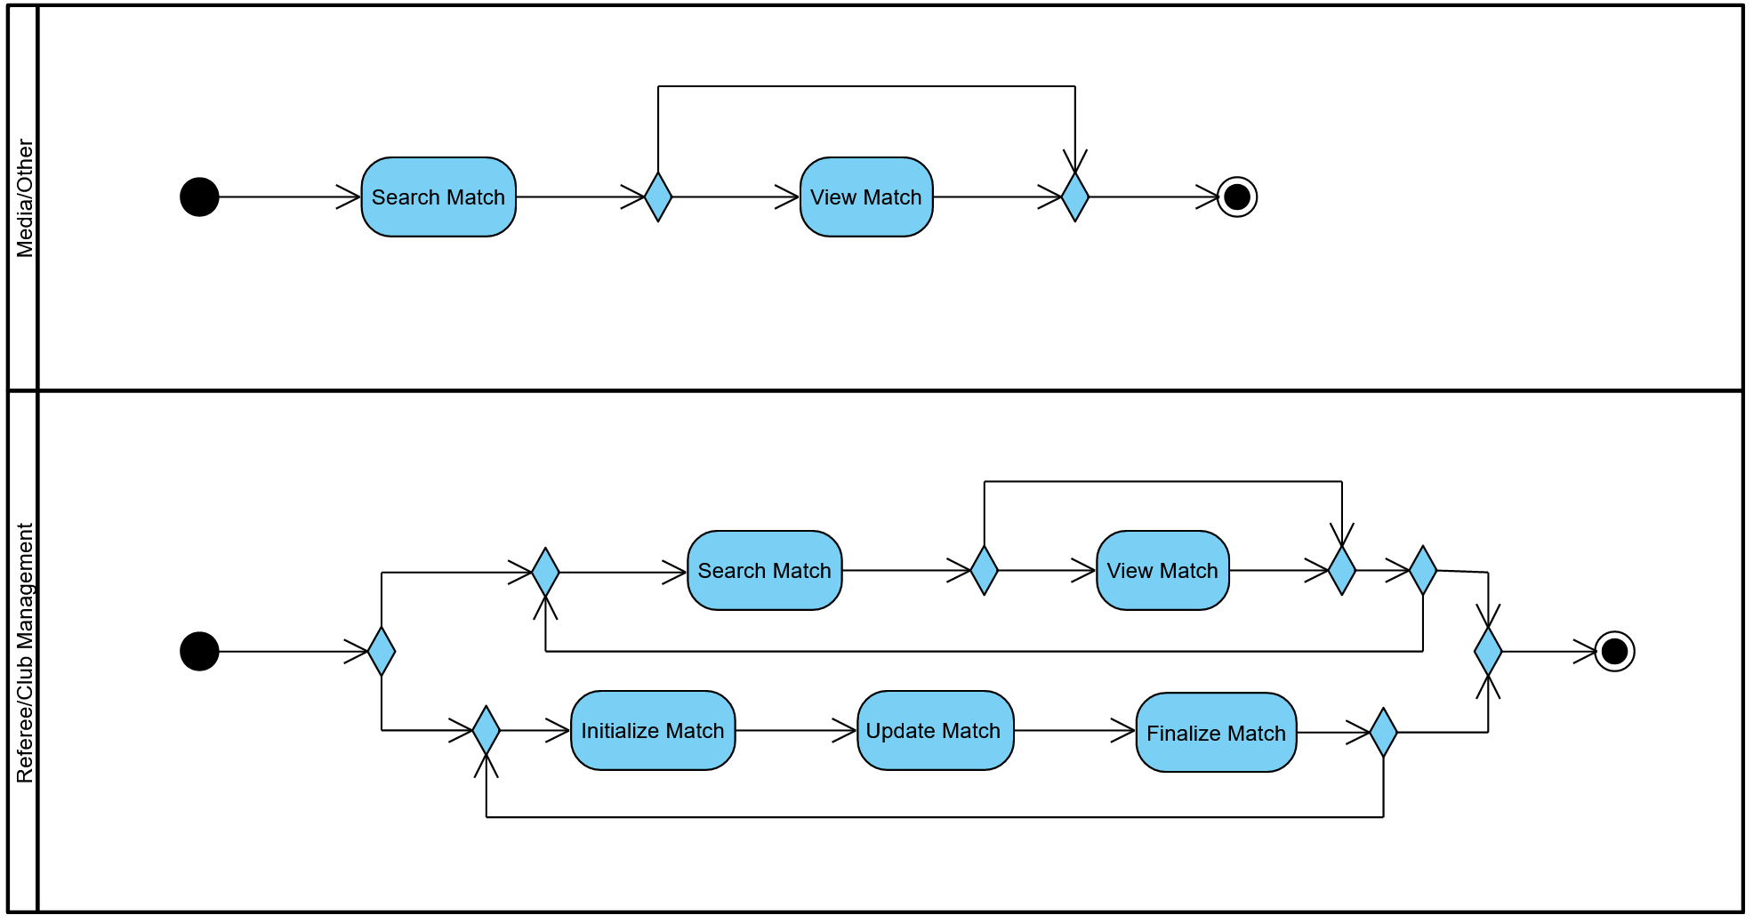The following Activity Diagram visualizes at what order the system features can be triggered.